EXERCISE 1
SIXOLISE KLAAS
DATA ANALYTICS (AUG)
07 AUG 2026

Question 1:List all distinct departments in the students table.
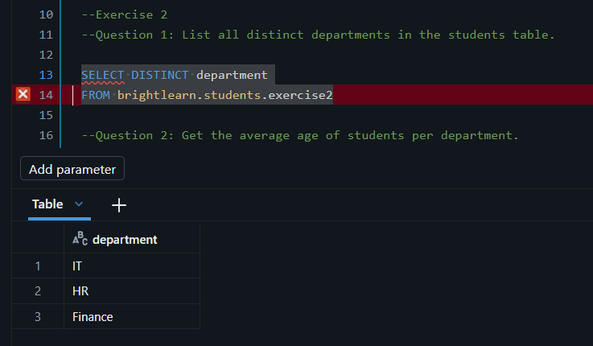

Question 2: Get the average age of students per department.
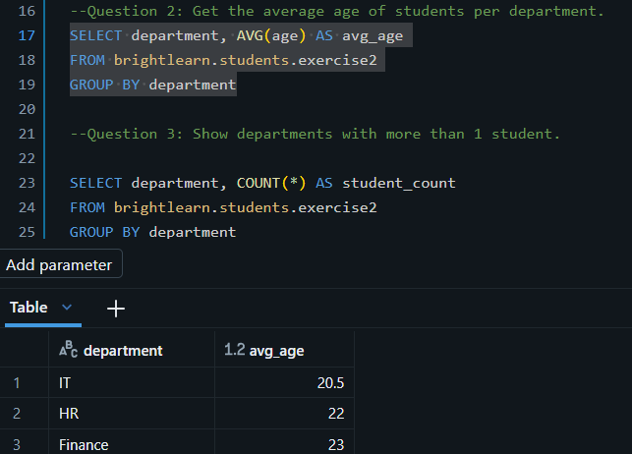

Question 3: Show departments with more than 1 student.
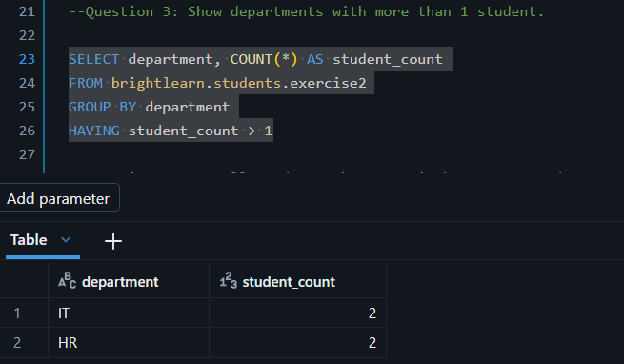

Question 4: Get all students whose age is between 21 and 23
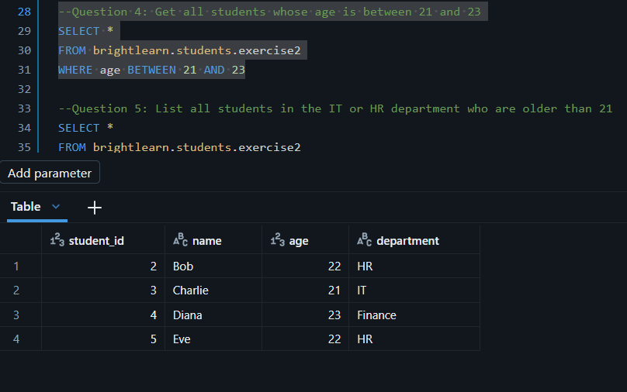

Question 5: List all students in the IT or HR department who are older than 21.
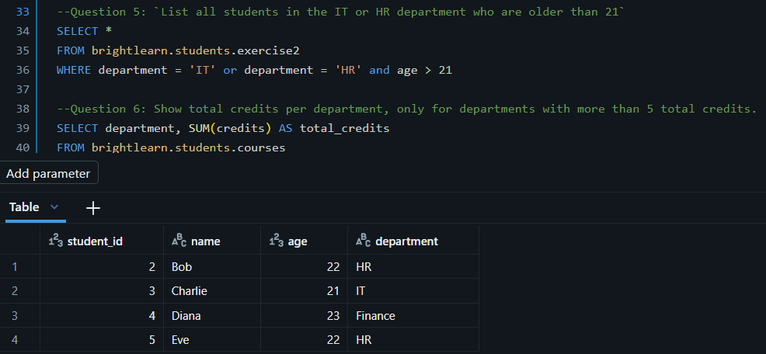

Question 6: Show total credits per department, only for departments with more than 5 total credits.
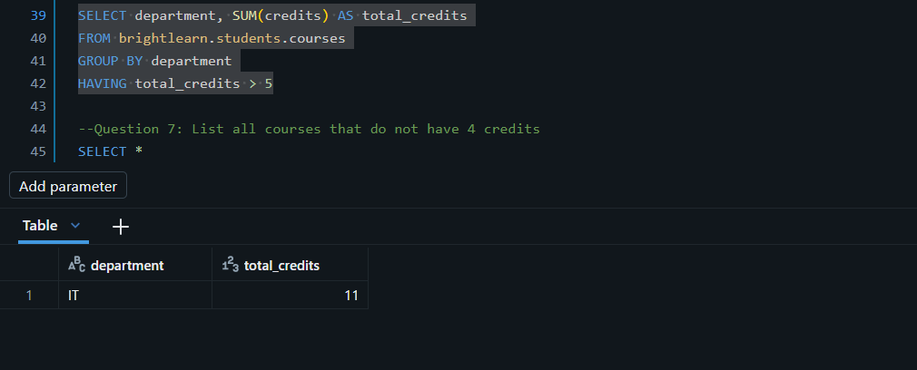

Question 7: List all courses that do not have 4 credits
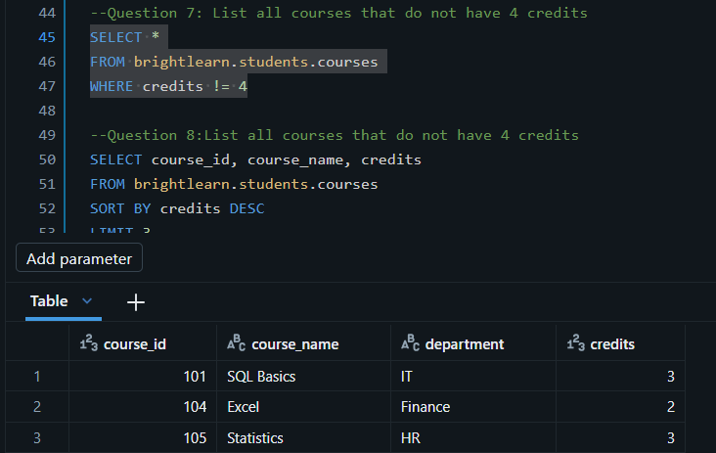

Question 8: List all courses that do not have 4 credits
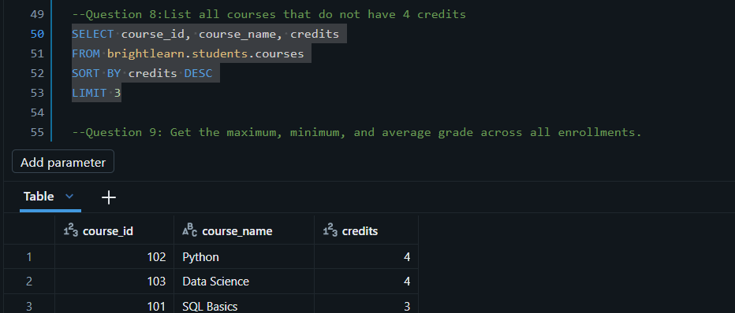

Question 9: Get the maximum, minimum, and average grade across all enrollments.
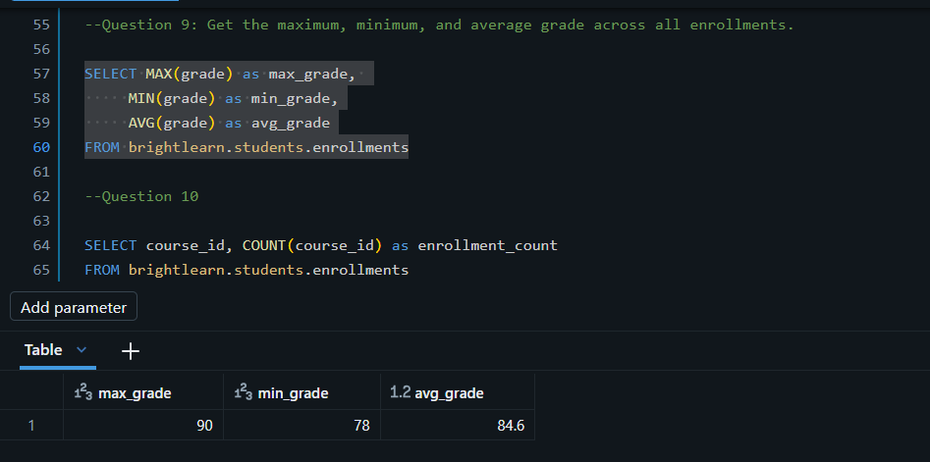

Question 10: Count how many enrollments exist per course.
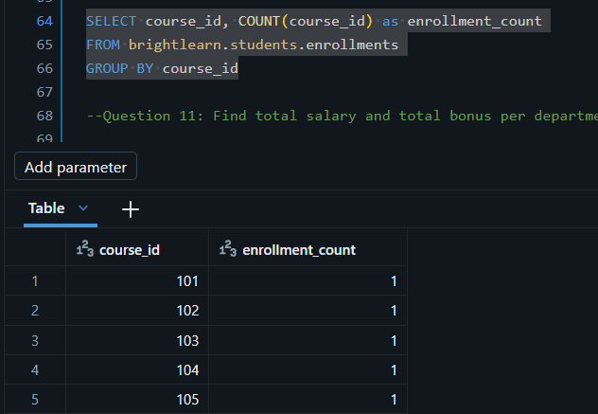

Question 11: Find total salary and total bonus per department
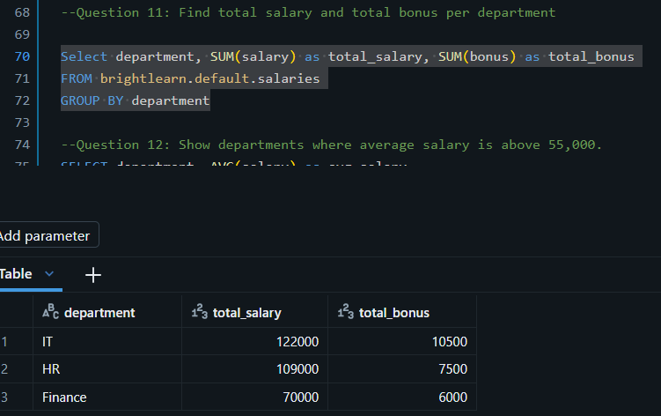

Question 12: Show departments where average salary is above 55,000.
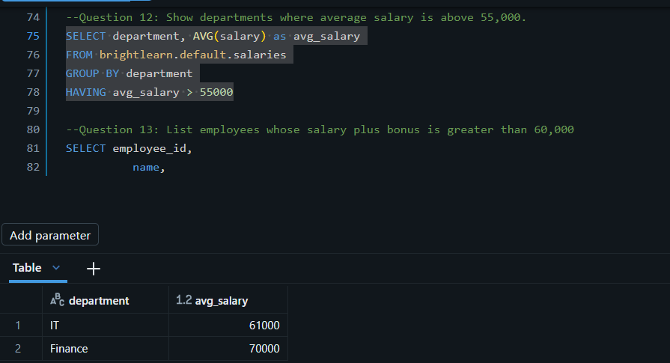

Question 13: List employees whose salary plus bonus is greater than 60,000
